CAT Grade 12
Content |  |  |  | Weeks |  | Activities
Theory | Network technologies: networks | - Wide area networks (WAN)  - Definition, purpose and role  - Internet as an example of a WAN  - Internet services (uses/purpose, advantages, disadvantages, limitations, examples):  - Real-time messaging - instant messaging and chat  - Voice over Internet Protocol (VoIP)  - File Transfer Protocol (FTP)  - File sharing  - Concept of grid computing and cloud computing  - Government Internet services and information such as tax return, TV licence payment and election information  - Make buying and informed decisions regarding Internet connection and access  - Modem/router, types of connections, e.g. ADSL, wireless technologies, including their advantages, disadvantages and limitations  - ISP, Internet services  - Consideration of access points, coverage (wireless)  - Data transmission speed - measured in kilobits per second(kbps) and megabits per second (mbps)  - CAP, bundle  - Concept of broadband and bandwidth  - Downloading/uploading | ± ½ week |  | Activity 1  1. Write down the correct answer for each of the following questions.  a. Which one of the following is NOT part of networking equipment?  A. Network cables  B. Network signaller  C. Hub  D. Router  b. An advantage of a WAN is that everyone on the network can access the same  data and _______.  A. Videos and photos  B. Information  C. News  D. All of the above  c. A disadvantage of a WAN is that the setting up of it can be _______.  A. Difficult  B. Time consuming  C. Expensive  D. All of the above  2. Choose a term or concept from Column B that matches the description in Column A.  Write only the letter next to the question number.  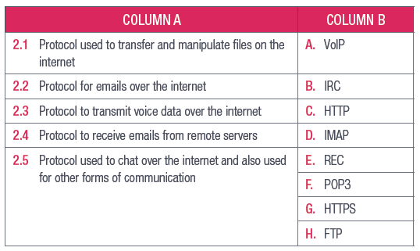  3. Say if the following statements are TRUE or FALSE. Correct the underlined word(s) if they are false.  a. An extender is a piece of hardware that can be added to a computer and makes it possible to connect to a network.  b. The internet is the best-known LAN.  c. A WAN is a computer network that covers a small area.  d. To create a wireless network, you only need two types of networking equipment: a WAP and a wireless network adapter.  e. In modern computers, the network adapters are built into the motherboard.  4. Answer the following questions.  a. What is a WAP and why is it important in a wireless network?  b. In your own words, describe what the internet is and why it is important in  modern society.  c. What role does an ISP play when connecting to the internet?  d. Large networks have changed the way in which we share and store information.  Name three additional advantages of large networks.  e. If you are looking to create a home network, what equipment will be needed?  Will this change when you want to connect the network to the internet?  f. What are the advantages and disadvantages of using a wireless network instead  of a wired network when connecting to the internet?  g. Give an example of where HTTPS protocol is used and how it differs from HTTP.  Activity 2  1. Write down the correct answer for each of the following questions.  a. Which one of the following is NOT an example of FTP services?  A. Pure FTPd B. FileZilla Server  C. ProFTPd D. FT protocol  b. Which one of the following is an example of instant messaging?  A. Wikipedia B. Facebook  C. Telegram D. YouTube  c. When you are in control of what you watch and when you want to watch it.  A. Cable B. Broadcast  C. Streaming D. Satellite television  2. Choose a term or concept from Column B that matches the description in Column A. Write only the letter next to the question number.  3. Say if the following statements are TRUE or FALSE. Correct the underlined word(s) if  they are false.  a. Netflix is more popular than M-Net.  b. Showmax is an example of a streaming service.  c. Electronic payments give users a free, simple and secure way to do their tax returns from home.  d. Instant messaging allows the user to make voice calls over the internet.  4. Answer the following questions.  a. What is the difference between cloud computing and grid computing?  b. Explain e-filing and give one advantage thereof.  c. Why would people want to use government internet services? Mention a  government institution that uses the internet.  d. List four advantages, one disadvantage and three examples of instant messaging.  e. Give two examples of apps on a smartphone that use the following internet services:  i. VoIP  ii. FTP  iii. Cloud computing and grid computing  iv. Cloud-based file sharing  v. Streaming  Activity 3  QUESTION 1: MULTIPLE CHOICE  1.1 What type of network is the internet? (1)  A. LAN  B. PAN  C. WAN  D. WHAN  1.2 Which of the following protocols sends web pages? (1)  A. IMAP  B. HTTP  C. VoIP  D. IMAP  1.3 Which of the following is NOT a service provided by ISPs? (1)  A. Instant messaging  B. World-wide web  C. Skype  D. Broadband  1.4 Which of the following is an example of an FTP? (1)  A. FileZilla Server  B. Amazon Web Services  C. MediaFire  D. Twitch  1.5 Which of the following is an advantage of government internet services? (1)  A. You can pay your water bills online  B. You can communicate through video conferencing  C. You can stand in shorter queues at SARS  D. You can find out where to pay your TV license [5]  QUESTION 2: TRUE OR FALSE  Indicate if the following statements are TRUE or FALSE. Correct the statement if it is false.  Change the underlined word(s) to make the statement true.  2.1 HANs can can be public and private. (1)  2.2 A WAP can be used to create a wireless network. (1)  2.3 FTP is used to connect computers in a network. (1)  2.4 Google Drive is Google’s instant-messaging platform. (1)  2.5 4G connections are a new technology of broadband. (1) [5]  QUESTION 3: MATCHING ITEMS  Choose a term or concept from Column B that matches a description in Column A. (5)  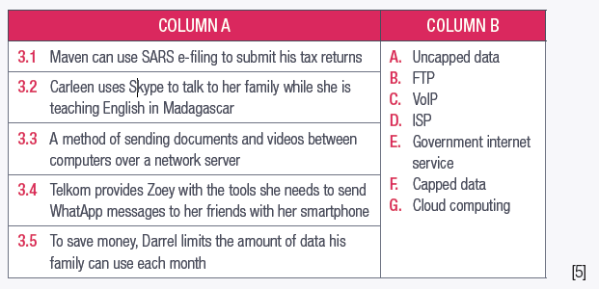  QUESTION 4: CATEGORISATION QUESTIONS  Look through the following advantages and disadvantages, and indicate to which internet service each belongs. (5)  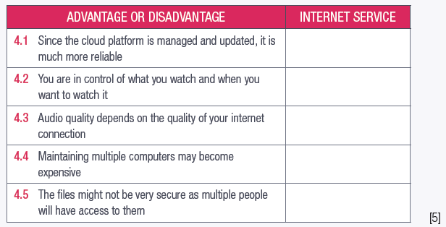  QUESTION 5: SCENARIO-BASED QUESTIONS  Your cousin is moving out of the house soon and has started investigating connectivity options. She is considering the following packages:  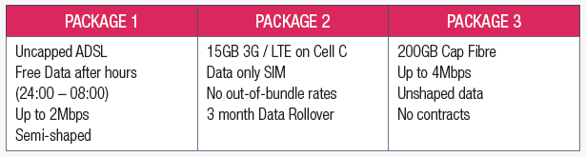  5.1 What does the term uncapped for package 1 mean? (1)  5.2 Explain why you would never be throttled on package 2 or 3? (1)  5.3 What does it mean when your internet connection is shaped? (2)  5.4 Which one of these packages has the highest speed? (1)  5.5 Refer to package 2: What does out-of-bundle rates refer to? (1)  Nkosi has to hold Skype conferences for his company for the next month. Recently, the company has been having serious problems with big clients; therefore, an emergency meeting can occur at any time, which means he must make sure he is readily available.  5.6 What should Nkosi consider when buying an internet connection for the next month? (4)  5.7 What internet specifications do you think would be best for him in this situation? Give a suggestion for each factor. (4)  5.8 Compare the difference between capped data and uncapped data. (4)  5.9 Explain to him what the purpose of a WAP is. (2) [14]
  COLUMN A | COLUMN B
  2.1 Example of cloud-based file sharing | A. VoIP
  2.2 Standard network protocol that is used to enable your computer to transfer files between the computer and the network server | B. SARS
  2.3 May use a lot of data when watching a video | C. HTTP
  2.4 An example of cloud computing | D. Microsoft Azure
  2.5 Where you pay your taxes | E. REC
  2.5 Where you pay your taxes | F. Dropbox
  2.5 Where you pay your taxes | G. Streaming
Theory | Social implications | - Social issues applicable to the above content:  - Computer crimes in relation to hardware, software, information, identity, bandwidth theft, theft of time and services  - Internet-related fraud scams  - Internet attacks  - Taking over PCs, e.g. bots, zombies  - Right to access vs right to privacy  - Misuse of personal information  - Security issues such as malware, spyware, adware, pop-ups, key logging and safe guards such as firewalls  - Avoiding security threats  - Safeguards against criminals, viruses and threats  - The impact of technology on the global community: Distributed computing power | ± 1 week |  | QUESTION 1: MULTIPLE CHOICE  1.1 Which of the following is NOT a computer-related crime? (1)  A. Downloading illegal software  B. Accessing hardware on a shared network  C. Stealing a network’s password  D. Hotlinking  1.2 What does DoS stands for? (1)  A. Denial-of-service  B. Data on server  C. Delivery of services  D. Digital office software  1.3 Which of the following can be used to launch DoS attacks? (1)  A. Spyware  B. Zombies  C. Worms  D. Phishing  1.4 Which of the following is NOT a result of telecommunication technologies? (1)  A. Meeting new people  b. Conducting business  C. Reducing pollution  D. Distributing computer power  1.5 What is the purpose of a firewall? (1)  A. Preventing other computers on a network from accessing your computer  B. Removing viruses on the computer  C. Detecting spyware programs  D. Installing anti-malware (1) [5]  QUESTION 2: TRUE OR FALSE  Indicate if the following statements are TRUE or FALSE. Correct the statement if it is false. Change the underlined word(s) to make the statement true.  a. Malware is software that can be used to cause harm to the user’s computer or computer network, without the user’s knowledge. (1)  b. Identity theft is when someone uses your credentials to access your personal information. (1)  c. You can prevent adware by being careful when installing new applications. (1)  d. All bots are malicious. (1) [4]  QUESTION 3: MATCHING ITEMS  Choose a term or concept from Column B that matches a description in Column A. (5)  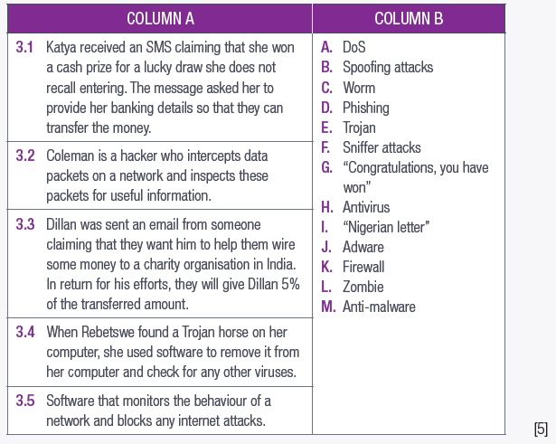  PART 6: SCENARIO-BASED QUESTIONS  6.1 Carlos recently downloaded a game online. Everything seemed fine at first, until he discovered a new hidden file on his computer. He soon started to notice that his hard-drive memory was starting to get used up, even though he was not installing any large files on his computer.  a. To what type of threat(s) has Carlos been exposed? (2)  b. What can Carlos use to get rid of this threat(s)? (1)  c. Suggest three precautionary measures Carlos could take to safeguard himself against internet attacks. (3)  d. Name five things Carlos could do in the future to protect himself from this type of threat(s). (5)  6.2 Mary downloads a lot of programs as a programmer and animator. Since Mary creates and maintains content for professional companies, she worries that her client’s private information could be at risk.  a. What would be the best safeguard for her current situation? (1)  b. Mention three benefits of the safeguard that you suggested. (3)  [15]
  QUESTION 4: FILL IN THE MISSING WORDS
  Fill in the missing word(s) in the following statements. Provide only ONE word for each space.
  a. Businesses create _______ for products in order to reach more customers. (1)
  b. _______ technologies saves users both _______ and money, as they do not have to invest in buying expensive processing equipment. (2)
  c. People can use _______ to meet new people from anywhere in the world. (1)
  d. Cell phones allow people to communicate over _______ distances and, therefore, save people money. (1)
  [5]
  QUESTION 5: SHORT QUESTIONS
  State if the following are internet attacks or not. (5)
  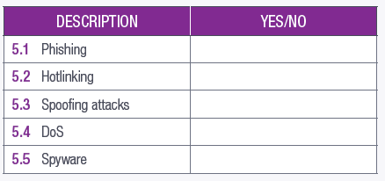
Practical and theory | Solution development: Html/Web design | - Reinforce content, concepts and skills as well as good website/page design  - HTML tables  - Syntax: Table tags  - Attributes: border, cell padding  - Develop a web page for a specific scenario | ± 1 week |  | Activity 1  1. Open Notepad ++  2. Insert the table tag.  <table>  </table>  3. Add rows and columns to the table.  <table>  <tr>  <td> Column A </td>  <td> Column B </td>  </tr>  </table>  4. Save as an HTML file.  This will create a basic table containing two columns, Column A and Column B.  Activity 2  Here is how to add a border to the table.  1. Insert the table tag.  <table>  </table>  2. Add the border attribute to the table opening tag.  <table border=”2”>  </table>  3. Add rows and columns to the table.  <table border=”2”>  <tr>  <td> Column A </td>  <td> Column B </td>  </tr>  </table>  This will create a basic table with a border around each of the cells.  Activity 3  Here is how to add a table name and table headings:  1. Start by naming the table using the caption tag.  <caption>  This is my table name.  </caption>  2. Insert the table tag and border attributes.  <caption>  This is my table name.  </caption>  <table border=”2”>  </table>  3. Add the table headings using the heading tag.  <caption>  This is my table name.  </caption>  <table border=”2”>  <tr>  <th> Heading A </th>  <th> Heading B </th>  </tr>  </table>  4. Add rows and columns to the table.  <caption>  This is my table name.  </caption>  <table border=”2”>  <tr>  <th> Heading A </th>  <th> Heading B </th>  </tr>  <tr>  <td> Column A </td>  <td> Column B </td>  </tr>  </table>  This will create a basic table named “This is my table” with the headings, Heading A and  Heading B.  Activity 4  Formatting HTML tables can be done as follows:  1. Start by naming the table using the caption tag.  2. Insert the table tag, border, width and height attributes.  <caption>  This is my table name.  </caption>  <table border=”2” width=”400” height=”150”>  </table>  3. Add the table headings using the heading tag.  4. Add rows and columns to the table.  <caption>  This is my table name.  </caption>  <table border=”2” width=”400” height=”150”>  <tr>  <th> Heading A </th>  <td> Column A </td>  </tr>  <tr>  <th> Heading B </th>  <td> Column B </td>  </tr>  </table>  Activity 5  You can change the colour of the table’s border by setting the border colour attribute. This can be  done as follows:  1. Start by naming the table using the caption tag.  2. Insert the table tag, border, and border colour attribute.  <caption>  This is my table name.  </caption>  <table border=”2” bordercolor=”blue”>  </table>  3. Add the table headings using the heading tag.  Add rows and columns.  This will create a table with a blue border.  Activity 6  Here is how to adjust the table cell spacing:  1. Start by naming the table using the caption tag.  2. Insert the table tags, cell spacing, and cell padding attributes.  <caption>  This is my table name.  </caption>  <table border = “1” cellpadding = “5” cellspacing = “5”>  </table>  3. Add the table headings using the heading tag.  4. Add rows and columns to the table.  This will create a table with a distance of 5 pixels between the cell borders and the cell content, and 5 pixels between each table cell.  Activity 7  Here is how to create a cell that spans over multiple rows and columns:  1. Start by naming the table using the caption tag.  2. Insert the table tag, border, width and height attributes.  <caption>  This is my table name.  </caption>  <table border=”2” width=”400” height=”150”>  </table>  3. Add the table headings using the heading tag.  4. Add rows and columns to the table.  <caption>  This is my table name.  </caption>  <table border=”2” width=”400” height=”150”>  <tr>  <th>Main Heading</th>  </tr>  <tr>  <th> Heading A </th>  <td> Column A </td>  </tr>  <tr>  <th> Heading B </th>  <td> Column B </td>  </tr>  </table>  5. Add the rowspan and colspan attributes to the <th> and <td> tags.  <caption>  This is my table name.  </caption>  <table border=”2” width=”400” height=”150”>  <tr>  <th colspan=3 style=”text-align:center”>Main  Heading</th>  </tr>  <tr>  <th rowspan=2 style=”text-align:center”>Main  Column</th>  <td style=”text-align:center”> Heading A </th>  <td style=”text-align:center”> Column A </td>  </tr>  <tr>  <th style=”text-align:center”> Heading B </th>  <td style=”text-align:center”> Column B </td>  </tr>  </table>
Practical | Solution development: spreadsheets | - Reinforce and consolidate content, concepts and skills  - Text functions such as:  - LEFT, RIGHT, MID, CONCATENATE, LEN, VALUE and FIND | ± ½ week |  | Activity 1  Open the spreadsheet GAct5.1(TextFunctions).xlsx. To extract the first two characters of each person’s first name, you will do the following:  1. Start the text function as normal: =LEFT  2. Add the cell that contains the data: =LEFT(B2  3. Add the number of characters you want to return: =LEFT(B2,2  4. End the formula by closing all parentheses: =LEFT(B2,2)  Activity 2  Open the spreadsheet GAct5.1(TextFunctions).xlsx. To extract the last four characters of each person’s last name, you will do the following:  1. Start the text function as normal: =RIGHT  2. Add the cell that contains the data: =RIGHT(A2  3. Add the number of characters you want to return: =RIGHT(A2,4  4. End the formula by closing all parentheses: =RIGHT(A2,4)  Activity 3  Open the spreadsheet GAct5.1(TextFunctions).xlsx. To create a special code for each person, you will extract two characters from each person’s name starting from the second character. This can be done as follows:  1. Start the text function as normal: =MID  2. Add the cell that contains the data: =MID(B2  3. Add the position of the first character that you want to return: =MID(B2,2  4. Add the number of characters you want to return: =MID(B2,2,2  5. End the formula by closing all parentheses: =MID(B2,2,2)  Activity 4  Open the spreadsheet GAct5.4(Concatenate).xlsx. Here is how to combine the data into a single cell:  1. In C2, start the text function as normal: =CONCATENATE  2. Add the position of the cell that contains the first piece of data: =CONCATENATE(B2  3. Add a space between the first and second piece of data: =CONCATENATE(B2,“ ”  4. Add the position of the cell that contains the second piece of data: =CONCATENATE(B2,“ ”,A2  5. End the formula by closing all parentheses: =CONCATENATE(B2,“ ”,A2)  Activity 5  1. Open the file saved with Guided Activity 5.4.  2. Start the text function as normal: =LEN  3. Add the cell containing the text that you want to determine the length of: =LEN(B2  4. End the function by closing all parentheses: =LEN(B2)  Activity 6  Open a blank spreadsheet and type the following:  TEXT STRING NUMERICAL VALUE  20%  2018/11/03  1:25 PM  R1 000  2. In Cell B2, start the text function as normal: =VALUE  3. Add the text string or cell containing the text string that you want to convert to a numerical value:  =VALUE(A2 or =VALUE(“20%  4. End the function by closing all parentheses: =VALUE(A2) or =VALUE(“20%)  Activity 7  1. Open the spreadsheet GAct5.7(Find).xlsx. In B2, start the text function as normal: =FIND  2. Add the string of character you are looking for: =FIND(“e”  3. Add the cell or text string containing the text that you want to search through: =FIND(“e”,A32  4. Add the position where the FIND function will start searching: =FIND(“e”,A32,1  5. End the function by closing all parentheses: =FIND(“e”,A32,1)  Activity 8  Open the spreadsheet GAct5.8(Combinations).xlsx. To display the grade in a new cell:  1. Use the LEFT function to indicate that you are looking to extract information from the left part of text string: =LEFT  2. Add the location of the text string: =LEFT(B2  3. Add the number of characters that should be copied. To determine this, we use the FIND function: =LEFT(B2,FIND  Add the value we are looking to find (in this case the comma between the grade and class): =LEFT(B2,FIND(“,”  Add the location of the text string: =LEFT(B2,FIND(“,”,B2  4. End the formula by closing all parentheses: =LEFT(B2,FIND(“,”,B2)).  5. To remove the comma from the end of Grade 12, we add -1 to the end of the function =LEFT(B2,FIND(“,”,B2)-1)  Activity 9  Open the GAct5.8(Combinations).xlsx spreadsheet you saved in Guided Activity 5.8 above. To display the class in a class cell:  1. Use the RIGHT function to indicate that you are looking to extract information from the right part of the text string: =RIGHT  2. Add the location of the text string: =RIGHT(B2  3. Add the number of characters that should be copied. To determine this, we start by using the LEN function to calculate the length of the whole text string (learner data) and the FIND function to identify the location of the space in the string. We then subtract the location of the space from the value of the whole string in order to determine the length of the class data:  =RIGHT(B2,LEN(B2)-FIND(“, ”,B2)).  Datafiles: https://1drv.ms/u/s!AgXqzm9lkwlHiwllQHiSAkF7GDUF?e=WSdcRc
Practical and theory | Solution development: Word Processing | - Reinforce and consolidate content, concepts and skills  - Mail Merge - different data sources, e.g. e-mail list  - File management: Prepare, publish | ± 1 week |  | https://www.youtube.com/watch?v=UusH-4DvFaw  Activity 1  1. Prepare the document by opening a new blank document. (It is also possible to use an existing letter.  Browse for it on your computer and open it before you open Mailings.) Click the Start Mail Merge  option located in the Start Mail Merge section of the Mailings tab. This will open a dropdown list.  2. Select the document type from the dropdown list. In this case it will be Letters.  3. Type the letter. You will only be typing the common parts of the letter, i.e. the text that does not change. Type the fields you need in ALL CAPS. This is to make it easier for you to find the text that must be replaced. Use short descriptive phrases. Save the main document.  4. Click the Select Recipients option and select Use an existing list. Browse for the list on your computer. (It could be a word processing table, spreadsheet or database.)  5. Edit the recipient list. Here you can sort or filter to find only those recipients you want to include.  For example, only Grade 12 learners who have achieved less than a certain percentage, or only recipients whose surnames start with certain letters.  6. Insert placeholders by going to the place where you want to insert personalised data and clicking the Insert Merge Field option. Select the field that you want to insert, for example Title, First Name or Email Address.  7. The Insert Merge Field menu will appear, showing the fields according to the recipient list.  To insert the field into the main document, highlight the placeholder in the text and choose the relevant field to replace the text in the document.  Continue adding fields until the document is complete.  7. Preview the final mail merge document by clicking Preview Results.  8. If you are happy with the document, click the Finish & Merge option, select Edit Individual Documents.  ●Select Complete Merge.  ●In the bottom left hand corner of your screen you will see that many pages are created, each containing personalised information.  Save the merged document (Letters) with a new name.  Activity 2  Do the following on your computer and save it as Act 2.1 (Your initials and surname).  You are turning 18 on the 10th of the month and are planning a party for the coming Saturday evening.  1. Create an invitation (your main document) to your friends, inviting them to the party. To make it  easier, you decided to do a mail merge for the invitation.  2. Add the following fields in the invitation:  ●Your guest’s name  ●Contact Number of guest  ●Name of partner  3. Make the mailing list for at least 12 names. Type a new list.  4. Save the merged document as Act2.1(Merged).  Save and close all documents.  Activity 3  1. Open the word document.  2. Choose the mail merge type from the Start Mail Merge dropdown list.  3. Click Select Recipients and select Use Existing List. This will open a new window asking you to choose the data source.  4. Select the Excel spreadsheet and click Open.  5. Select the sheet where the data is located and click OK. This will now connect the spreadsheet to the word document.  6. Click Insert Merge Field and select the field that you want to be included in the document from the Insert Merge Field dialog box.  7. Repeat Step 6 until all the relevant fields have been inserted.  8. Preview the final mail merge document by clicking Preview Results. You can navigate through the document by using the Next and Previous buttons.  9. If you are happy with the document, click the Finish & Merge option and select the option that will best work for you.  Activity 4  Importing data to word can be done like this:  1. Click the Object dropdown list located in the Text section of the Insert tab.  2. Click Text from File.  3. Select the file and click Insert.  The contents of the file has been inserted in a new document.  Activity 5  Work in the 6Data_Data document to prepare a mail merge for return slips.  - Use the 52Type_Tipe table of the 5Cyber_Kuber database as the data source.  - Select only Grade 10 male learners who reported cyberbullying to their parents.  - Add the merge fields Name_Naam and Surname_Van in the space provided in the table.  - Right align the merged fields Name_Naam and Surname_Van and ensure that there is a space between the two fields.  - Save the document as 6Ready_Gereed.  - Complete the merge and save the new merged document as 6Merge_Saamvoeg.  Save and close the document 6Data_Data.

